# Best Programming Practice

1. All values as variables including Fixed, User Inputs, and Results
2. Avoid Hard Coding of variables wherever possible
3. Proper naming conventions for all variables String name = "Eric"; double height = input.nextDouble();

double totalDistance = distanceFromToVia + distanceViaToFinalCity;

1. Proper Program Name and Class Name
2. Follow proper indentation

1. **Sample Program 1 -** Write a program to display Sam with Roll Number 1, Percent Marks

99.99, and the result ‘P’ indicates Pass(‘P’) or Fail (‘F’).

IMP => Follow Good Programming Practice demonstrated below in all Practice Programs

// Creating Class with name DisplayResult indicating the purpose is to display

// result. Notice the class name is a Noun. class DisplayResult {

public static void main(String[] args) {

// Create a string variable name and assign value Sam

String name = "Sam";

// Create a int variable rollNumber and assign value 1 int rollNumber = 1;

// Create a double variable percentMarks and assign value 99.99 double percentMarks = 99.99;

// Create a char variable result and assign value 'P' for pass

char result = 'P';

// Display the result

System.out.println("Displaying Result:\n" +name+ " with Roll Number " + rollNumber+ " has Scored " +percentMarks+

"% Marks and Result is " +result);

}

}

2. **Sample Program 2 -** Eric Travels from Chennai to Bangalore via Vellore. From Chennai to Vellore distance is 156.6 km and the time taken is 4 Hours 4 Mins and from Vellore to Bangalore is 211.8 km and will take 4 Hours 25 Mins. Compute the total distance and total time from Chennai to Bangalore

// Create TravelComputation Class to compute the Distance and Travel Time class TravelComputation {

public static void main(String[] args) {

// Create a variable name to indicate the person traveling

String name = "Eric";

// Create a variable fromCity, viaCity and toCity to indicate the city

// from city, via city and to city the person is travelling

String fromCity = "Chennai", viaCity = "Velore", toCity = "Bangalore";

// Create a variable distanceFromToVia to indicate the distance

// between the fromCity to viaCity double distanceFromToVia = 156.6;

// Create a variable timeFromToVia to indicate the time taken to

// travel from fromCity to viaCity in minutes int timeFromToVia = 4 * 60 + 4;

// Create a variable distanceViaToFinalCity to indicate the distance

// between the viaCity to toCity double distanceViaToFinalCity = 211.8;

// Create a variable timeViaToFinalCity to indicate the time taken to

// travel from viaCity to toCity in minutes int timeViaToFinalCity = 4 * 60 + 25;

// Create a variable totalDistance to indicate the total distance

// between the fromCity to toCity

double totalDistance = distanceFromToVia + distanceViaToFinalCity;

// Create a variable totalTime to indicate the total time taken to

// travel from fromCity to toCity in minutes int totalTime = timeFromToVia + timeViaToFinalCity;

// Print the travel details

System.out.println("The Total Distance travelled by " + name + " from " + fromCity + " to " + toCity + " via " + viaCity +

" is " + totalDistance + " km and " +

"the Total Time taken is " + totalTime + " minutes"); }

# Level 3 Practice Programs

1. Write a TemperaturConversion program, given the temperature in Celsius as input outputs the temperature in Fahrenheit

## Hint =>

1. Create a ***celsius*** variable and take the temperature as user input
2. Use the Formulae Celsius to Fahrenheit: (°C × 9/5) + 32 = °F and assign to ***farenheitResult***  and print the result

## I/P => celcius

**O/P =>** The ____ celsius is _____ fahrenheit

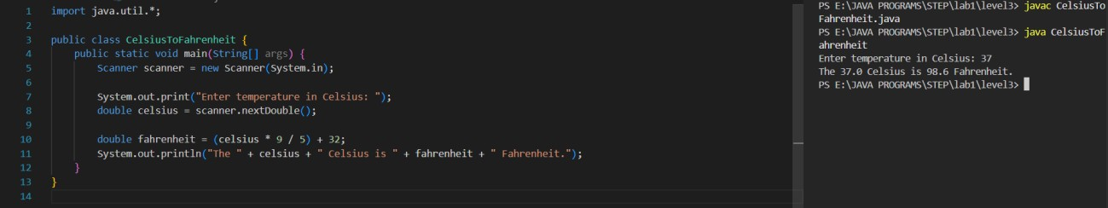

2. Write a TemperaturConversion program, given the temperature in Fahrenheit as input outputs the temperature in Celsius

## Hint =>

1. Create a ***fahrenheit*** variable and take the user's input
2. User the formulae to convert Fahrenheit to Celsius: (°F − 32) x 5/9 = °C and assign the result to ***celsiusResult***  and print the result

**I/P =>** fahrenheit

**O/P =>** The ____ fahrenheit is _____ celsius

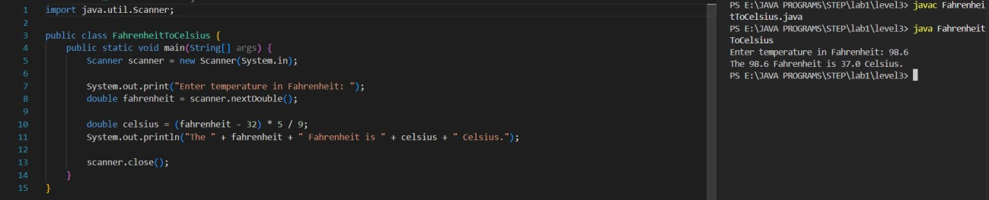

3. Create a program to find the total income of a person by taking salary and bonus from user

## Hint =>

1. Create a variable named salary and take user input.
2. Create another variable bonus and take user input.
3. Compute income by adding salary and bonus and print the result

**I/P =>** salary, bonus

**O/P =>** The salary is INR ___ and bonus is INR ___. Hence Total Income is INR ___

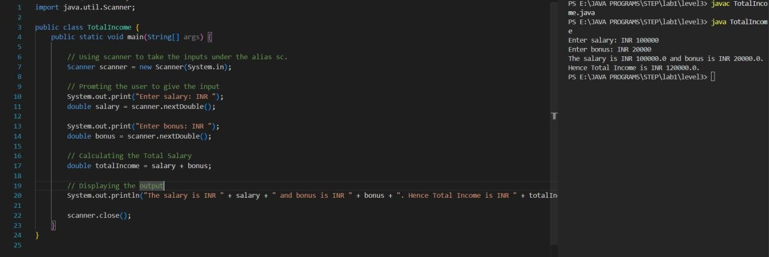

4. Create a program to swap two numbers

## Hint =>

1. Create a variable number1 and take user input.
2. Create a variable number2 and take user input.
3. Swap number1 and number2 and print the swapped output

**I/P =>** number1, number2

**O/P =>** The swapped numbers are ___ and ___

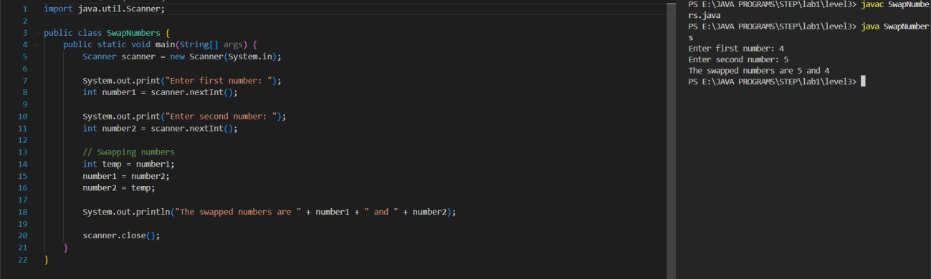

5. Rewrite the Sample Program 2 with user inputs

## Hint =>

1. Create variables and take user inputs for name, fromCity, viaCity, toCity
2. Create variables and take user inputs for distances fromToVia and viaToFinalCity in

Miles

1. Create Variables and take time taken
2. Finally, print the result and try to understand operator precedence.

**I/P =>** fee, discountPrecent

**O/P =>** The results of Int Operations are ___, ___, and ___

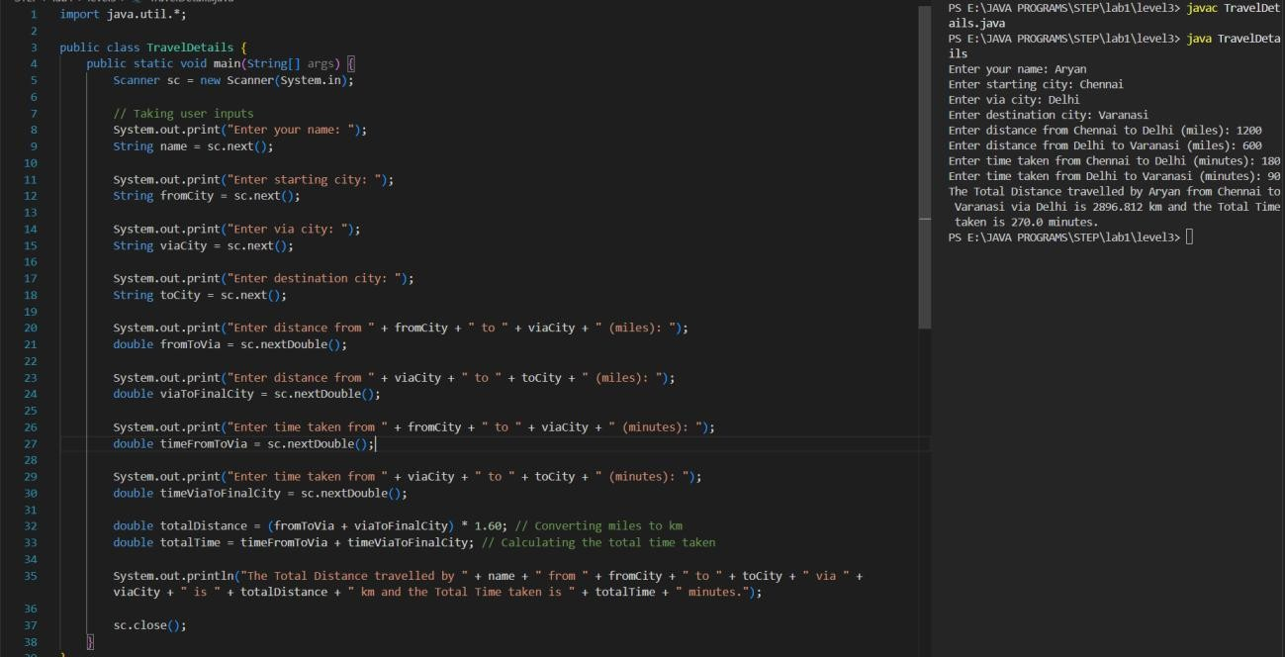

1. An athlete runs in a triangular park with sides provided as input by the user in meters. If the athlete wants to complete a 5 km run, then how many rounds must the athlete complete

**Hint =>** The perimeter of a triangle is the addition of all sides and rounds is distance/perimeter **I/P =>** side1, side2, side3

**O/P =>** The total number of rounds the athlete will run is ___ to complete 5 km

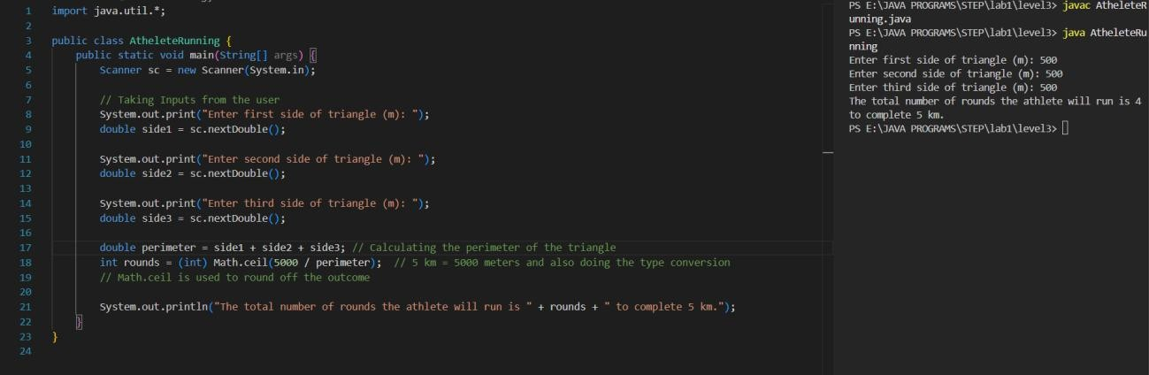

1. Create a program to divide N number of chocolates among M children.

## Hint =>

1. Get an integer value from user for the numberOfchocolates and numberOfChildren.
2. Find the number of chocolates each child gets and number of remaining chocolates c. Display the results

**I/P =>** numberOfchocolates, numberOfChildren

**O/P =>** The number of chocolates each child gets is ___ and the number of remaining chocolates are ___

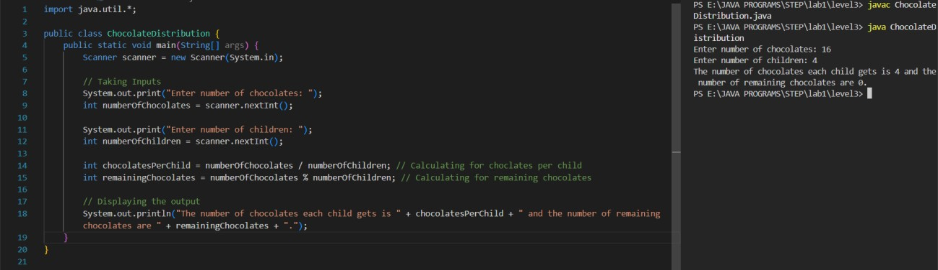

1. Write a program to input the Principal, Rate, and Time values and calculate Simple Interest.

**Hint =>** Simple Interest = Principal * Rate * Time / 100

**I/P =>** principal, rate, time

**O/P =>** The Simple Interest is ___ for Principal ___, Rate of Interest ___ and Time ___

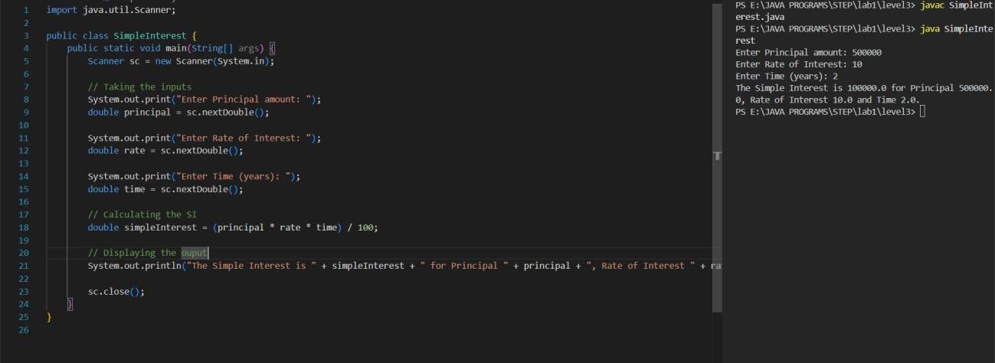

1. Create a program to find the maximum number of handshakes among N number of students.

## Hint =>

1. Get integer input for numberOfStudents variable.
2. Use the combination = (n * (n - 1)) / 2 formula to calculate the maximum number of possible handshakes.
3. Display the number of possible handshakes.

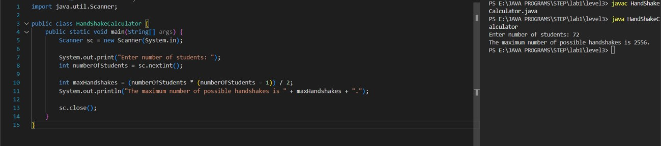

10. Create a program to convert weight in pounds to kilograms.

**Hint =>** 1 pound = 2.2 kg

## I/P => weight

**O/P =>** The weight of the person in pound is ___ and in kg is ___

